**Pneumonia Detection Using Convolutional Neural Network**

**Project report of**

**Year V Semester-X**

**By**

**Name of the students:**

**Aagam Parekh C067**

**Hasshya Shah C082**

**Varshil Shah C083**

**Nemil Shah C086**

**Name of the Mentor**

**Prof. Archana Nanade**

**Prof. Abhay Kohle**



**Department of Computer Engineering**

**Mukesh Patel School of Technology Management & Engineering**

**NMIMS (Deemed-to-be University), Mumbai**

| Sr No. | Table of Content | Page No. |
| --- | --- | --- |
| 1. | Introduction | 2 |
| 2. | Background Work | 3 |
| 3. | Proposed System | 4-6 |
| 4. | Working/Implementation | 7-9 |
| 5. | Experimental Results | 10-12 |
| 6. | Conclusion and Future work | 13 |
| 7. | References | 14 |

**1. INTRODUCTION**

Pneumonia is a serious respiratory illness involving lung inflammation and buildup of pus and fluids in the air sacs. The two main types are bacterial and viral pneumonia. Bacterial pneumonia causes more severe, acute symptoms and requires antibiotic treatment, while viral pneumonia often resolves on its own. Pneumonia is a prevalent global health issue, with pollution a major contributing factor. In the U.S., it ranks 8th among leading causes of death. The burden is immense in developing countries like India, where an estimated 3.7 lakh children die from pneumonia annually, accounting for 50% of total pneumonia deaths. Pneumonia frequently goes undetected until an advanced stage, especially in the elderly. It is the leading infectious killer of children under 5 worldwide. The WHO estimates pneumonia claims 1.4 million under-5 lives per year, 18% of all deaths in this age group. While treatable, there is an urgent need for improved, low-cost diagnostic methods to reduce childhood pneumonia mortality in high-burden regions. Early and accurate diagnosis is key for timely, appropriate treatment and better outcomes.

Chest X-rays are one of the important and efficient method for pneumonia diagnosis due to their widespread availability. In regions with limited healthcare resources, computer-aided diagnosis using deep learning, particularly convolutional neural networks (CNNs), offers a cost-effective solution. Deep learning models can classify pneumonia accurately and precisely from X-ray images, supplementing clinical decision-making. We propose a deep transfer learning algorithm to automatically extract features from X-ray images, aiding in pneumonia detection.Various CNN models, ResNet, and DenseNet have been proposed, and several works have been done to identify pneumonia using CNN. Densenet proved to be very accurate because of its dense convolutional neural networks. Each layer gets an additional input from all previous layers and passes the current features which it extracted to all the following layer.The output of the DenseNet convolutional layer is the input feature maps' concatenated values. For optimal flow of the entered data, DenseNet connects all levels densely.

**2. LITERATURE SURVEY**

Deep learning methodology has been used in multiple fields of medical to identify disease using X-rays [1-2]. M.I.Razaak [3] discussed the limitations and the future of image processing in medical. Multiple proposed models have been implemented for the detection of various diseases by using deep learning based models, stated by Dinggang Shen [4].Techniques about the detection of disease by chest X-ray have also been worked by performing various examination techniques [5]. The method was stated by S. Hermann [6]. Nasrullah[7] used two deep three-dimensional customized mixed link network architectures for detecting lung disease detection and classification. Another study presents a 161-layer DenseNet-based neural network model that predicts pneumonia with 85% accuracy using chest X-ray data. The model seeks to accelerate pneumonia detection by utilizing decoupled weight decay regularization and a lower learning rate, which may help radiologists in clinical settings by M. S. Anggreainy [8], This paper which is written by Amal H. Alharbi and Hanan A. Hosni Mahmoud[9], proposes an AI system for analyzing CT scans of COVID-19 patients to assess the severity of lung inflammation. The system utilizes CNN models trained on large datasets for accurate analysis, emphasizing the significance of automated tools in diagnosing respiratory diseases, especially during pandemics. This paper which is written by Abbas M.Ali, Kayhan Ghafoor ,Aos Mulahuwaish and Halgurd Maghdid[10] introduces the Improved BoxENet model for pneumonia detection from X-ray images, incorporating transfer learning and X-ray segmentation techniques. It emphasizes the novelty of combining pre-trained models, deep learning architectures, and segmentation methods to enhance detection accuracy across various datasets. The paper proposed by Amit Ranjan, Chandrashekhar Kumar, Rohit Kumar Gupta and Rajiv Mishra[11] specifically details the utilization of DenseNet161 architecture in pneumonia detection, employing transfer learning techniques. It highlights the modification of the model's fully connected layer for binary classification tasks and the integration of attention mechanisms for enhanced classification performance. The study showcases the effectiveness of combining DenseNet161 with other models, achieving high accuracy in pneumonia detection.

The paper by Rohit Kundu,Ritacheta Das,Zong Woo Geem,Gi-Tae Han[12] addresses the causes and impacts of pneumonia, emphasizing the importance of early diagnosis for improved patient outcomes. The paper describes the development of a system for pneumonia detection using CNN models like GoogleNet, ResNet, and DenseNet, with weighted average optimization. It underscores the challenges associated with pneumonia diagnosis and the potential of deep learning methods to enhance accuracy.

This paper by N.Krishnamoorthy,K.Nirmaladevi,T.Kumaravel,K S Sanjay Nithish[13]focused on the severity of lung diseases, particularly pneumonia, in young children, this paper discusses the limitations of clinical diagnosis and the adoption of CNN models like VGG16 for improved detection accuracy. It stresses the need for reliable diagnostic tools, considering the severity and prevalence of such diseases.

**3. PROPOSED SYSTEM**

We propose a model which uses transfer learning to predict the class of the x ray scan of the patient. We integrated two existing models which are densenet 161 and resnet 34. Before sending the data to the model we are augmenting the images to increase the dimensionality of the images. We have added a classifier layer which is tailored according to our classification task, while leveraging transfer learning to utilize the knowledge from the pre - trained models.

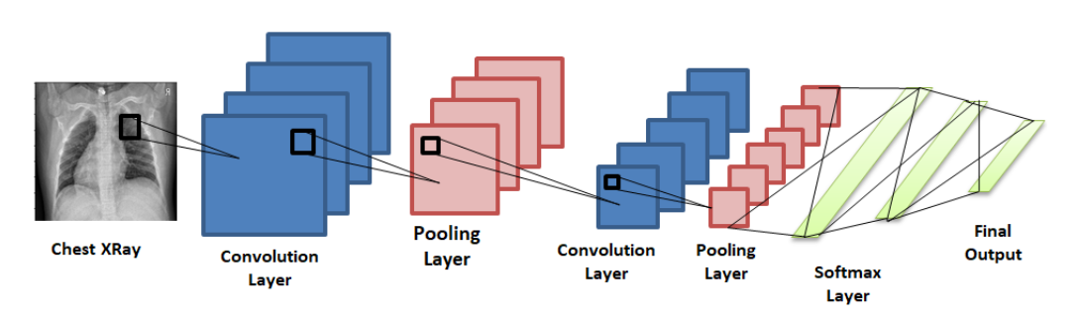

**Figure 1(a) - Proposed System**

Figure. Convolutional neural network consisting of input image passing through convolution layers and pooling layers connected to the final classifier layer.

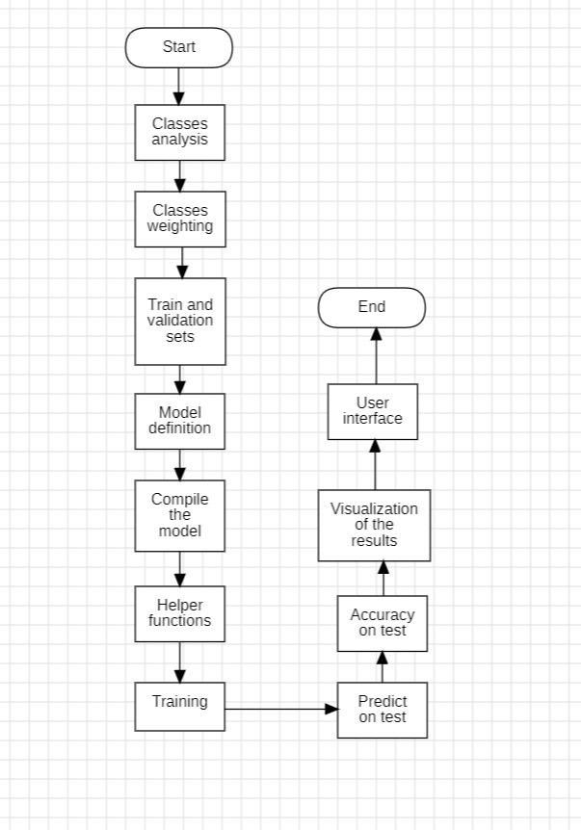

Figure 1(b) - CNN

**3.1 *Transfer Learning***

Transfer learning means that a model trained on one task is used as a basis to solve another problem. In transfer learning, an issue is resolved by using a model that was learned on one task as a foundation. For certain applications, transfer learning starts with pre-trained models rather than requiring the laborious process of training with initialized weights. In order to solve these problems, it thus helps to preserve the computer resources needed to build a neural network.

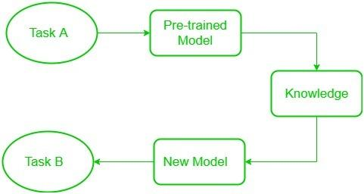

Figure 2. Transfer Learning

**3.2 *Pre-Trained Neural Networks Used***

***3.2.1 Densenet-161***

Dense connectivity within Convolutional Neural Networks (CNNs), exemplified by architectures like Residual Networks and Dense Convolutional Networks (DenseNet), enhances their effectiveness by ensuring strong connections between input and output layers. Unlike traditional CNNs, these architectures feature dense blocks where each layer is directly linked to every other layer within the same block, preserving consistent feature map dimensions. This design not only enables efficient feature reuse but also addresses challenges such as the vanishing gradient problem while substantially decreasing the parameter count required for training.

Densenet 161 consists of the following layers:

* Convolutional layer (at the beginning)
* Dense Block 1 (comprising multiple convolutional layers)
* Transition Layer 1 (combining convolutional and pooling operations)
* Dense Block 2
* Transition Layer 2
* Dense Block 3
* Transition Layer 3
* Dense Block 4
* Global Average Pooling Layer

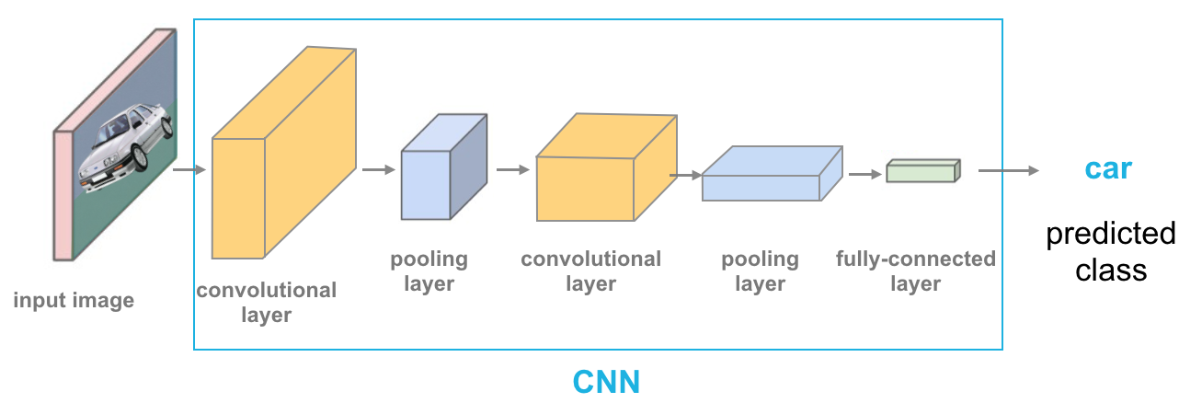

Figure 3 - DenseNet Architecture

In our proposed model the image size is 256 * 256 and after applying the densenet architecture the in-feature of the classifier has become 2208 and the out feature is 1000

***3.2.2 Resnet-34***

ResNet-34 is a variant of the Residual Network (ResNet) architecture, featuring 34 layers. It incorporates a fundamental innovation known as residual connections, enabling the network to learn residual mappings instead of directly learning the underlying mapping.

* Input Layer: This initial layer accepts input data, commonly images, for tasks such as image classification.
* Convolutional Layers: Following the input layer, the data traverses through several convolutional layers, responsible for extracting essential features from the input.
* Residual Blocks: ResNet-34 comprises multiple residual blocks stacked sequentially. Each block contains several convolutional layers along with residual connections. These connections, also known as skip connections, add the original input to the output of the convolutional layers, facilitating the learning of residual functions. ResNet-34's architecture includes several blocks with varying depths, contributing to its 34-layer structure.
* Pooling Layers: Integrated within the network are pooling layers, often max-pooling, which serve to reduce spatial dimensions and mitigate overfitting by downsampling the feature maps.
* Fully Connected Layers: Towards the latter part of the network, fully connected layers receive the high-level features extracted by the convolutional layers. These layers then make predictions based on these features, commonly generating class probabilities in classification tasks.

ResNet-34's architectural depth enables it to capture intricate features and representations from the input data. Additionally, the inclusion of residual connections addresses challenges like the vanishing gradient problem, facilitating the effective training of deep neural networks.

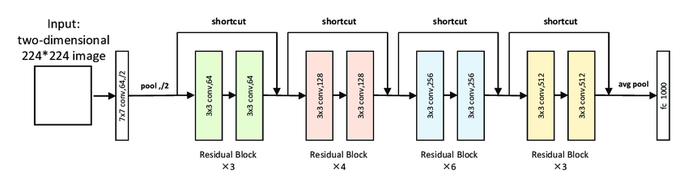

**Figure 4 - ResNet Architecture**

**4. Implementation**

***4.1 Experimental dataset:***

The dataset which we selected had 5836 images in total which was labelled in 2 categories, i.e. Normal and Pneumonia. The images were x-ray scans of patients who went for a clinical checkup and it was labelled by 2 physicians before being posted. The labels were also cross checked by another physician for validating the correctness of the same. At the end the dataset was divided into train and test which was 88.05% and 11.95% respectively. Fig 1. shows the data split and fig. 2 shows the x-ray scans for both the labels.

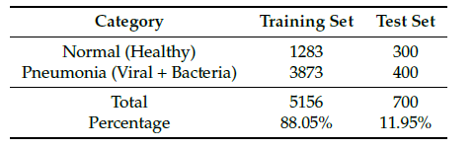

Figure 5

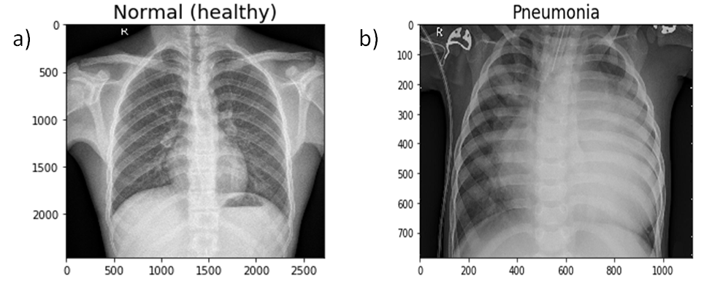

Figure 6

***4.2 Proposed Methodology:***

We found a solution to detect whether the patient has pneumonia or not by doing transfer learning on the densenet161 model. Then we added our layers to the densenet161 architecture and compiled the model. We then trained the model, for visualizing the performance while training, we created helper functions which were showing the model performance in real time. Then the performance was visualized on a graph. At last we created a user interface for quick access and presentation of the model performance. The picture below shows the flow of the project.

***4.3 Pre-Processing:***

We started off by doing some basic EDA in which we found that there was class imbalance with the images with the label pneumonia be significantly higher than the other so we decided to give weights to the labels. After assigning the weights, we did data augmentation as the current dataset was too small to give accurate results. In data augmentation, we flipped the images horizontally, cropped the center and rotated them randomly

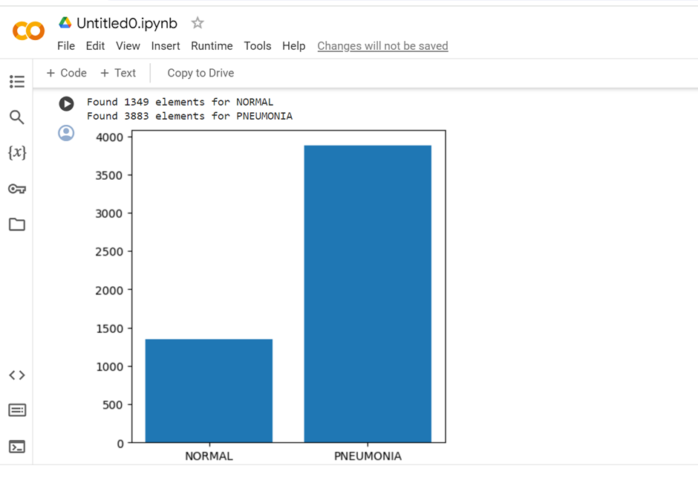

Figure 7

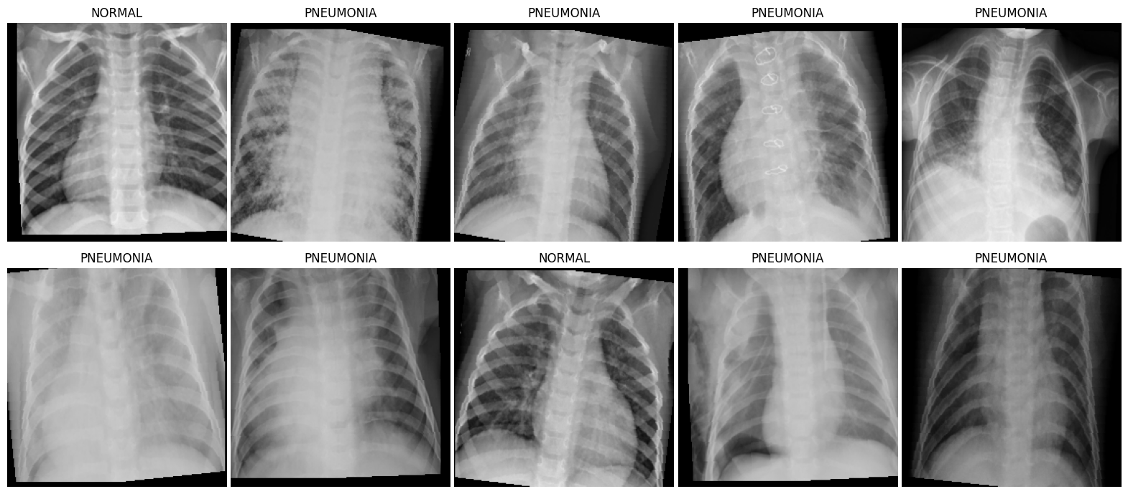

Figure 8

***4.4 Model Hyperparameters:***

| **Architecture** | **Image Size** | **Epochs** | **Optimizer** | **Learning Rate** | **Step Size** | **Gamma** |
| --- | --- | --- | --- | --- | --- | --- |
| Densenet161 | 256 x 256 | 15 | Adam | 0.001 | 4 | 0.1 |
| Resnet 34 | 256 x 256 | 15 | Adam | 0.001 | 4 | 0.1 |

***4.4 User Interface:***

We've developed a user-friendly interface leveraging Gradio as our frontend framework, facilitating an interactive experience for our model. With this interface, users can effortlessly upload chest X-ray images and receive instant outputs directly within the frontend environment. This intuitive design ensures seamless interaction, allowing users to conveniently access the functionalities of our model without any technical hurdles. Our goal is to provide a streamlined and accessible platform that enhances the user experience while leveraging the power of our model for analyzing chest X-ray images.

**5. Experimental Results**

The evaluation techniques used by us to evaluate the efficiency of our proposed methodology. We used the chest X-ray image dataset.The Pytorch open-source deep learning library was used to create a neural network with gradio as the frontend was used, first we load the pre-trained architectures on the chest X- rays Dataset and then fine-tuned it for optimization. All the computation work was done on google colab GPU as it provide efficient computation resources

***5.1 Graph of Testing Accuracy and Testing Loss***

***5.1.1 Densenet 161***

In order to assess and test the performance of our network, we conducted an experiment. We fine-tuned the parameters and hyperparameters of the model in the training process. Below figure shows the graph of training accuracy as well as training loss curves obtained while training the model for 15 epochs.

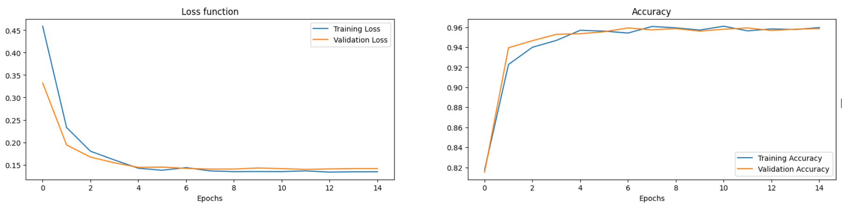

Figure 9(a),9(b)

Figure 9(a) training accuracy and training loss curves as well as Validation accuracy and Validation loss for densenet-161 architectures over the training dataset and it was trained for 15 epochs

The accuracy for the model on training was at about 96%, and the training loss for all the models was at around 0.2 and validation loss is 0.14.

Below table shows architecture’s testing accuracy and testing loss.

| Model Architecture | Testing accuracy | Testing loss |
| --- | --- | --- |
| Densenet 161 | 95% | 0.1414 |
| Resnet 34 | 93.82% | 0.163 |

The accuracy, precision, F1, AUC score,recall for each model in order to test the performance of the model.Confusion matrices was produced in order to compute the scores as shown in below figure The confusion matrix calculate the score for the number of true positives,, false positives, and false negatives, true negatives which aided in assessing the model's effectiveness.

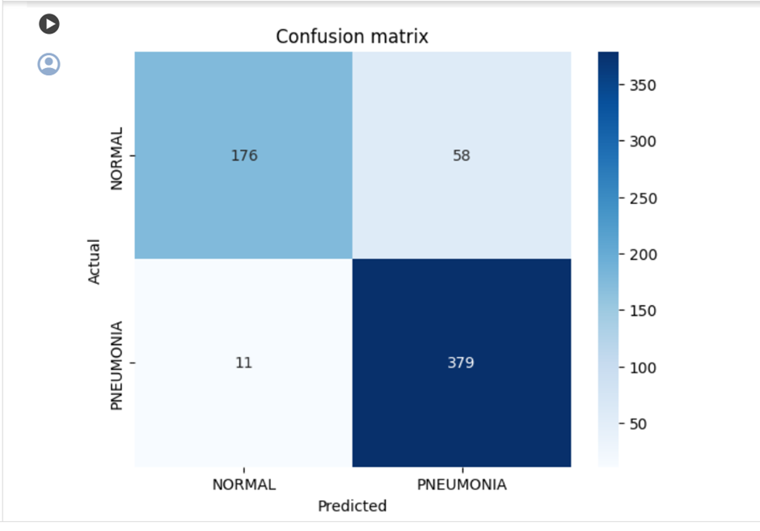

Figure 10(a)

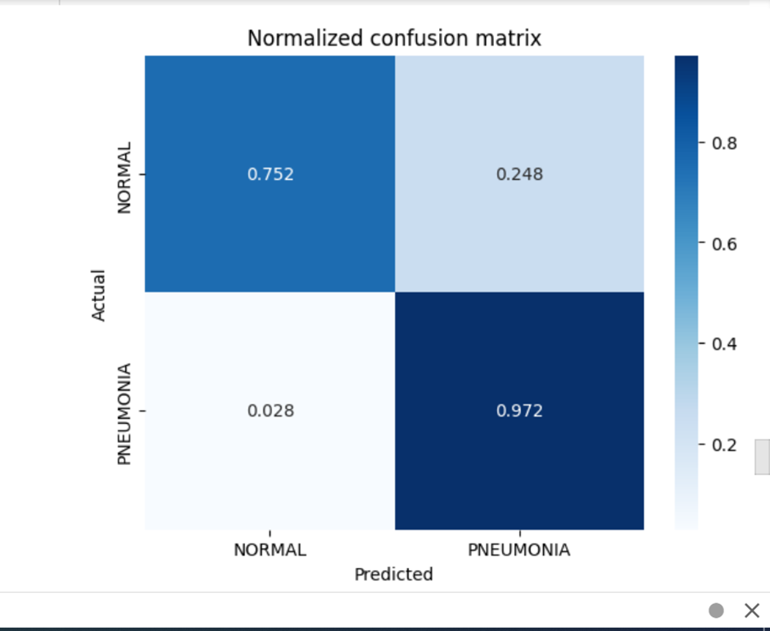

Figure 10(b)

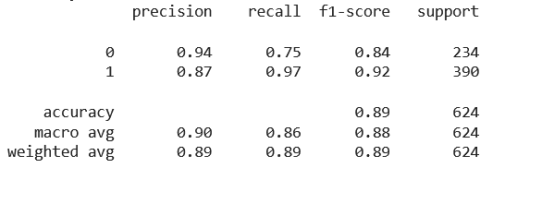

Figure 10(c)

Below are the screenshots of our model’s prediction and shows how accurately our model predicted on the test data

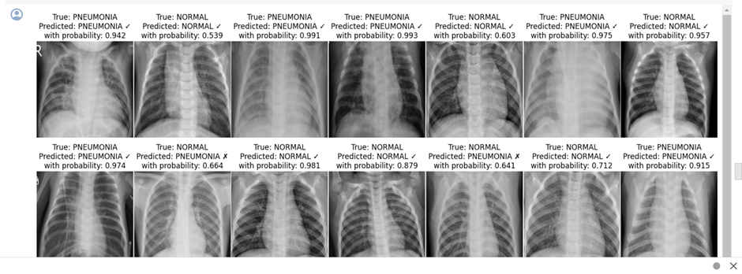

Figure 11(a)

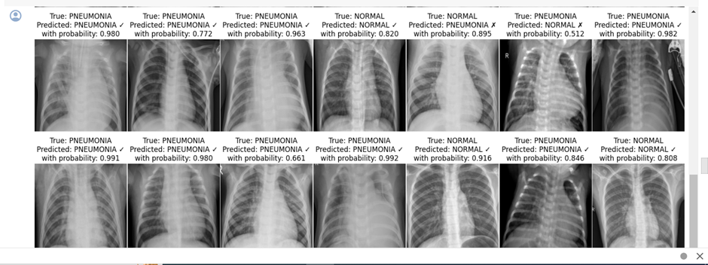

Figure 11(b)

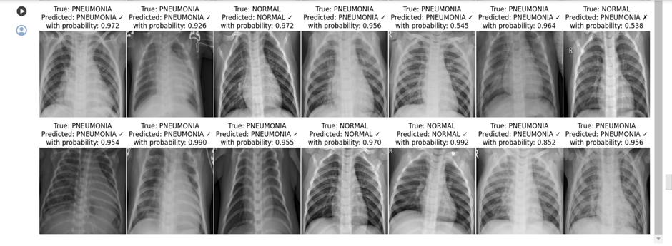

Figure 11(c)

***5.2.2 Resnet 34***

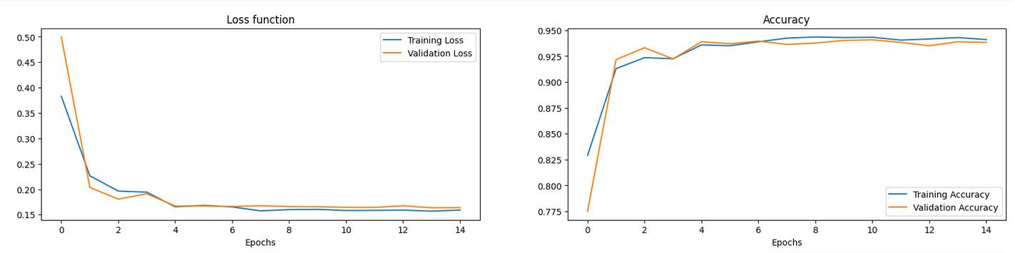

Figure 12(a)

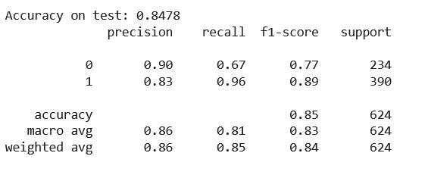

Figure 12(b)

**6. CONCLUSION AND FUTURE WORK**

The utilization of transfer learning combined with the DenseNet161 architecture yielded impressive outcomes in pneumonia detection from chest X-ray images. The model showcased a robust training accuracy of 96% and a notable testing accuracy of 95.4% on the validation dataset, underscoring its efficacy in accurately categorizing pneumonia cases. This study underscores the potential of deep learning methodologies, particularly transfer learning and convolutional neural networks, in crafting reliable diagnostic tools for pneumonia identification.

While the current model demonstrates promising performance, there are several potential avenues for future exploration. Firstly, augmenting the dataset with greater diversity and volume could bolster the model's ability to generalize and perform effectively across varied demographics and healthcare environments. Additionally, investigating ensemble techniques by amalgamating multiple deep learning architectures or integrating clinical data alongside X-ray images could potentially enhance the overall accuracy and dependability of pneumonia diagnosis. Furthermore, extending the model's capabilities to detect and classify diverse pneumonia types or other respiratory ailments could expand its utility in clinical settings. Lastly, deploying the model in real-world scenarios and conducting prospective studies would offer valuable insights into its practical applicability and facilitate further enhancements.

Moreover, there's an intention to leverage and implement additional models to enhance performance and attain superior classification accuracy. The plan also involves leveraging ensemble methods to amalgamate models, leveraging the distinct characteristics of each to improve classification and prediction outcomes.

**7. REFERENCE**

1. Douarre, C.; Schielein, R.; Frindel, C.; Gerth, S.; Rousseau, D. Transfer learning from synthetic data appliedto soil–root segmentation in x-ray tomography images. J. Imaging 2018, 4, 65.
2. Zhang, Y.; Wang, G.; Li, M.; Han, S. Automated classification analysis of geological structures based on images data and deep learning model. Appl. Sci. 2018, 8, 2493
3. Razzak, M.I.; Naz, S.; Zaib, A. Deep learning for medical image processing: Overview, challenges and the future. In Classification in BioApps; Springer: Cham, Switzerland, 2018; pp. 323–350.
4. Shen, D.; Wu, G.; Suk, H.I. Deep learning in medical image analysis. Annu. Rev. Biomed. Eng. 2017, 19, 221–248.
5. Avni, U.; Greenspan, H.; Konen, E.; Sharon, M.; Goldberger, J. X-ray categorization and retrieval on the organ and pathology level, using patch based visual words. IEEE Trans. Med. Imaging 2010, 30, 733–746.
6. Hermann, S. Evaluation of scan-line optimization for 3D medical image registration. In Proceedings of the IEEE Conference on Computer Vision and Pattern Recognition, Columbus, OH, USA, 23–28 June 2014;
7. Nasrullah, N.; Sang, J.; Alam, M.S.; Mateen, M.; Cai, B.; Hu, H. Automated Lung Nodule Detection and Classification Using Deep Learning Combined with Multiple Strategies. Sensors 2019, 19, 3722
8. M. S. Anggreainy, A. Wulandari and A. M. Illyasu, "Pneumonia Detection using Dense Convolutional Network (DenseNet) Architecture," *2021 4th International Seminar on Research of Information Technology and Intelligent Systems (ISRITI)*, Yogyakarta, Indonesia, 2021
9. Alharbi AH, Hosni Mahmoud HA. Pneumonia Transfer Learning Deep Learning Model from Segmented X-rays. Healthcare (Basel). 2022 May 26;10(6):987. doi: 10.3390/healthcare10060987. PMID: 35742039; PMCID: PMC9223174.
10. Ali, A.M., Ghafoor, K., Mulahuwaish, A. *et al.* COVID-19 pneumonia level detection using deep learning algorithm and transfer learning. *Evol. Intel.* **17**, 1035–1046 (2024).
11. Amit Ranjan(B), Chandrashekhar Kumar, Rohit Kumar Gupta, and Rajiv Misra Department of Computer Science and Engineering, Indian Institute of Technology Patna, Patna 801103, India
12. Kundu, R., Das, R., Geem, Z. W., Han, G.-T., & Sarkar, R. (2021). Pneumonia detection in chest X-ray images using an ensemble of deep learning models. PLoS ONE, 16(9), e0256630. https://doi.org/10.1371/journal.pone.0256630
13. N. Krishnamoorthy, K. Nirmaladevi, T. Kumaravel, K. S. Sanjay Nithish, S. Sarathkumar and M. Sarveshwaran, "Diagnosis of Pneumonia Using Deep Learning Techniques," 2022 Second International Conference on Advances in Electrical, Computing, Communication and Sustainable Technologies (ICAECT), Bhilai, India, 2022, pp. 1-5, doi: 10.1109/ICAECT54875.2022.9807954.